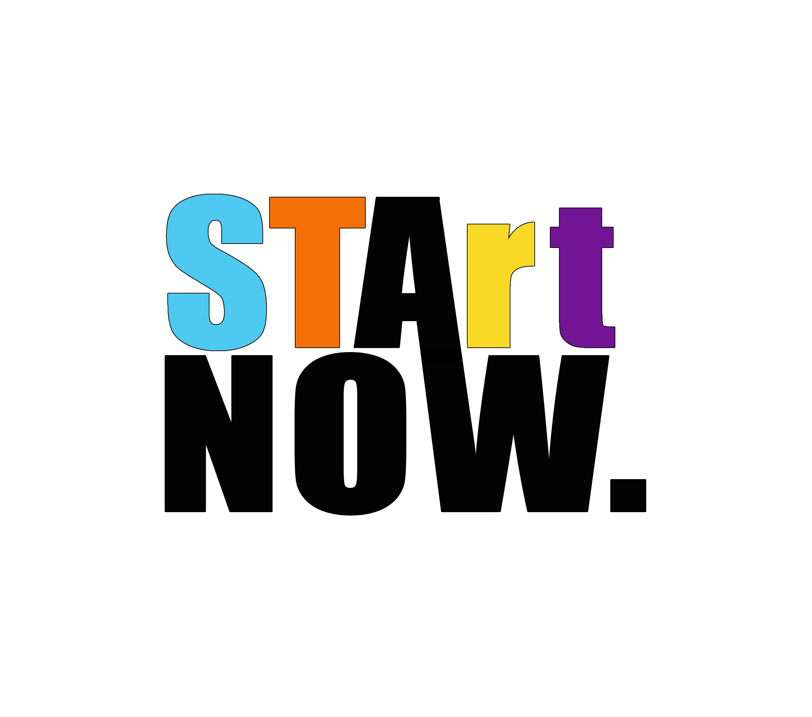
Our Contact Info
Email: STArtNowFlorida@gmail.com FaceBook.com/STArtNow
Office Phone # 904-295-3873
Our mission at STArt Now is to assist artists of all genres, types, and mediums with obtaining the tools of their trade, information, and education to produce their art form. Our goal is to always have an uninterrupted freedom of self for ourselves and the artisans we seek to help.
Artisan Questionnaire Form

Basics…. We’ve Gotta Know This Stuff
Full Name: |  | Date: |  | How did you hear about us?:
What is your Medium?:
Musical Soloist or Group ?: | Both? | Phone Number:
Main Artistic Skill:  Specify talent | Performance Visual Musical
Secondary Skill:
Musician Artist Both

Q&A….. You’ve Gotta Answer This Stuff
When was your last paid booking or commission? Details, Please:
How long have you been a paid Artist/Musician:
Specify as soloist, group, session, lead or fill in

Do you have any future bookings or commissions?
If so, how far out?:
Is it routine or stand alone?

Can you provide venues you have previously worked at or shown at?:
Is your artistic skill your main source of income?

#Goals …..Dun Dun Duuunnnn
Do you have a 1 to 3-year Goal for your art or music? ( Basic, life, financial or whatever you’ve got)

If so, please tell us about it! We want to know!!!

What is your biggest artistic concern right now? The reason you are here filling out this form!?

How can we at STArt Now help you? It’s a big question, so let’s try and keep the answers focused on immediate needs and issues

Would you be willing to volunteer for us in the future?
(Example: Performance at a benefit or volunteer your time to help at a fundraiser)

The Last question is WHY YOU? What do we need to know about you and your art or music that makes you- you!? Please answer this in less than 5 paragraphs and attach it if you need to. No fluff just the real answers.

Before you hand me this paper, just remember I am here to actually help you. Not to criticize you or change you- I want to figure out how I and STArt Now can do that. Now go back through your answers and change what you need to so we can get some stuff done together!!!

